**Crop Data Analysis of Indian Region using Big Data Techniques** **for aiding Indian farmers**



By

Ashutosh Anand,

Vineet Rathore and

Aman Sharma

**Abstract:**



Agriculture or farming is the largest contributor to the GDP of our country. Approximately 70 percent of rural household’s primary source of income is agriculture. But still farmers don’t get results worth their efforts. As a matter of fact, the condition of farmers in our country is horrible. The agriculture supports nearly 50 percent of the employment but contributes only 15 percent to the Gross Domestic Product (GDP). Due to variations in climatic conditions, improper crop selection or irrigation often leads to less yield than expected. On the other note, in the field of Information Technology, Big Data and Machine Learning has come forth as a blazing topic. So by using Big Data approach in analysing the crop data over various factors such as soil type, temperature, water level, humidity, soil pH, fertilizers, we will devise an algorithm that will predict which crop should be sown in which season that both the yield and the profit can be maximized. For fulfilling the above task, we have used Hadoop framework, Machine Learning and NoSQL Database.

**1. Introduction**

The Big Data Analysis is process of inspecting, cleansing and modelling the data with the purpose of discovering useful information and conclusions. It is a process of analysing, extracting and predicting the meaningful information from huge data in order to gain some pattern. This process is used by companies to turn the raw data of their customer to useful information. This analysis can also be used in the field of Agriculture. Most farmers generally rely on their previous experiences on a particular crop to expect a higher yield of that crop in the next harvesting season. But still the they don’t get result/income worth their efforts. The above listed problems are the recurring problems that all the farmers have to face. But we also know that during modern times, our environment is affected by global warming, pollution, acid rain, bio-waste and e-waste, so conditions keep changing drastically, and therefore traditional farming techniques and only past experiences are not sufficient. Hence, there is a need new and more reliable farming techniques that can meet the requirements of the country. As a result, Government is also taking many initiatives to improve farming. One of them is it is making data of previous farming records. But the problem with it is that the record or the dataset has become very large and can not be handled or analysed accurately with old methods. Furthermore doing so is also a very time consuming process. That’s where Big Data comes into play. By using Big Data Analysis, we can analyse large amount of data and find the underlying pattern within it precisely and efficiently.

**2. Literature Review**



In today’s world, more and more people are using electronic devices, surfing the web and using the social medias, thereby generating vast amount of data which mainly compromises of semi- structured and unstructured data. But the problem is that the data is highly unstructured and is present in large amount, so analyzing them by traditional means is a tedious and time consuming task without high chances of errors in outcomes. Fortunately, this problem in modern world can be solved to a great extent by using Big Data. Big Data is more real in comparison to another techniques for processing huge data. Massively data processing, scaling out architectures are unit compatible for big data applications.

Govt. of India created an open data ecosystem for the motive of sharing crop dataset as per National Data Sharing and Accessibility Policy (NDSAP) initiated Open Government Data (OGD).

Indian Prime Minister Narendra Modi -led government has asked Indian Council of Agriculture Research (ICAR) to prepare a chairmanship of Praveen Rao, comprehensive crop plan for India. A committee under the vice chancellor, Prof Jayashankar Telangana State Agriculture University, has been constituted for this purpose, Trilochan Mohapatra, Director General,

ICAR said, “The committee is expected to come out with a set of crop recommendations for each geography after considering the climatic conditions, soil health, water stress and the estimated short-term as well as long term demand for the produce within the country and globally”. The need to reorient India's agriculture practices and systems was one of the key recommendations of the high-level committee that was tasked with the job of finding ways to double farmers' income. The technical, scientific and economical feasibility of crops will be looked at a granular level due to the agro-climatic diversity of the country, Mohapatra said. According to him, water, the most critical element for any farming exercise, is fast becoming a scarce resource, and hence calls for urgent interventions at every level of agriculture. We have taken the dataset from the government website data.gov.in/crop. Our dataset consists of the data of all the states which consist of their districts and the production of crops with their respective seasons. The dataset further consists of area of the districts.

Figure: 2.1 Initial Dataset

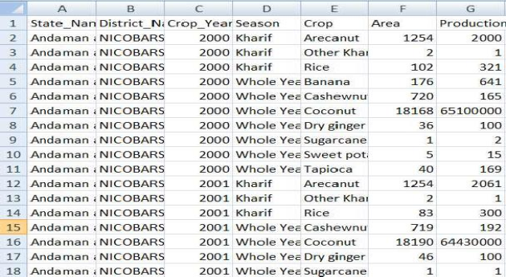

One of the most important aspect of analyzing a data requires cleaning of dataset. We removed ”crop year” column because of some redundancy. We used “pandas” which is a famous library of python that takes data (like a CSV or TSV file, or a SQL database) and creates a python object with rows and columns called data frame that looks very similar to table in a statistical software. It is mainly used for data manipulation and data analysis.

We used group by function of pandas to group our states with their respective districts and seasons. We used aggregate function to retrieve the average of the area and the production of the crop in a particular season of a district. Further we added a new column named as “P/A” which shows about production per area of a particular of a respective season with districts.

Figure 2.2 Updated Dataset

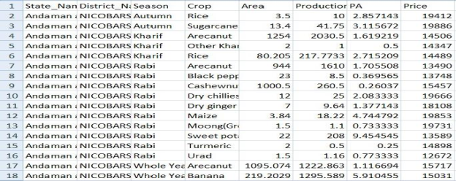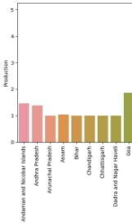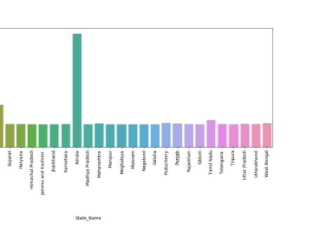

Data visualization is very important to represent the features of data in graphical form to understand complicated relationship in data. Standardizing the data is essential need before visualization. We used MinMaxScaler of sci-kit learn library to standardize the dataset. We plotted bar graphs using seaborn library.

Figure 2.3 Graph of State name v/s production

Figure 2.4 Graph of state name v/s “P/A”

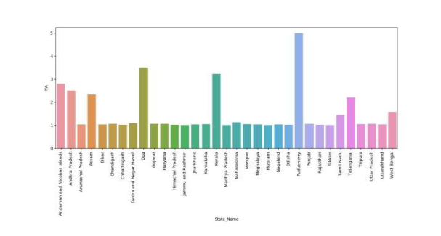

*Here, P/A represents production of crop per unit area*

The trend of social media is increasing rapidly. Almost all the peoples are active on social media platforms like facebook, instagram, twitter etc. On these platforms we post text messages, images, audio files, video files. More than millions of people use these platforms it means more than billon of messages and to store these messages there is a database which is present. These messages can be stored in RDBMS but RDBMS is not efficient to store and process the data which is more than 1 million and this type of data is a unstructured data and RDBMS is not able to store unstructured data so here NOSQL databases comes into picture. NOSQL databases are efficient to store and process the unstructured, semi structured as well as structured data also.

MongoDB is used to store the data comprising of more than 33,000 documents.

Here, we are connecting our Mongoose database with node.js with the help of mongoose.js library, modeling (ODM) library that provides a rigorous modeling environment for your data, enforcing structure as needed while still maintaining the flexibility that makes MongoDB powerful. After that we are embedding mongoDB queries in nodeJS by which it will process the input data given by the user and will print the desired output from database by taking the given input into account.

**3. Future Prospective**



The technology in our time is changing and improving fast. Life has come to smart phones and tablets from desktops and laptops and everyone own smart phones. As of now this application is only available for farmers as a web application but the android application of this project will also be made by which some more problems of farmers will get reduced. Android application will be based on location-based services, by which farmers will have to make less efforts, they won’t need to type or select anything, they will just open up the application and on the basis of their location and choices, results will get displayed.

In future, on this project ML lib will be applied which is an apache spark's scalable machine learning library by using this library many algorithms like regression, clustering, collaborative and classification will get implemented on this application by which it will give better results and will predict more results.

**References:**



[1] Ch. Chandra Shekhar, J. Uday Kumar, B. Kishore Kumar, Ch. Shekhar, Effective use of Big Data Analytics in Crop planning to increase Agriculture Production in India.

[2] Open data ecosystem as per National Data Sharing and Accessibility Policy (NDSAP)

initiated Open Government Data (OGD) Platform, 

[3] M. Moorthy, R. Baby and S. Senthamaraiselvi, “An Analysis for Big Data and its Technologies”, International Journal of Computer Science Engineering and Technology (IJCSET), vol. 4, no. 12, (2014) December, pp. 412-418.

[4] A. Pal, K. Jain, P. Agrawal and S. Agrawal, “A Performance Analysis of MapReduce Task with Large Number of Files Dataset in Big Data Using Hadoop”, 4th International Conference on Communication Systems and Network Technologies (CSNT), Bhopal, doi: 10.1109/CSNT.2014.124, (2014), pp. 587-591.

[5] K. Grolinger, M. Hayes, M. Hayesm, A. L'Heureux and D. S. Allison, “Challenges for MapReduce in Big Data”, 2014 IEEE World Congress on Services, June 27-July 2, IEEE Computer Society Washington, DC, USA © 2014, pp. 182-189.

[6] G. Nasrin Fathima, et al., “Agriculture Crop Pattern Using Data Mining Techniques”,IJARCSSE, Volume 4, Issue 5, May 2014, ISSN: 2277 128X, pp. 781-786.

[7] Joseph O. Chan, “An Architecture for Big Data Analytics”, IIMA, Volume 13 Issue 2, 2013, pp. 1-14

[8] Steve Sonka, “Big Data and the Ag Sector: More than Lots of Numbers”, IFAMA, Volume 17 Issue 1, 2014, pp. 1-20

[9] IEEE International Conference by CSI on Big Data on IT in Business, Industry and Government (CSIBIG), March 8-9, 2014, ISBN: 978-1-4799-3063-0

[10] Anirban Mukherjee, et. al., “Shared Disk Big Data Analytics with Apache Hadoop”, 978- 1-4673-2371-0/12© 2012 IEEE

[11] Yang, et. al., "Data Clustering on Taiwan Crop Sales under Hadoop Platform", Proceedings of the Institute of Industrial Engineers Asian Conference 2013